# PF LAB

# NAME: Mehreen Fatima

# SAPID: 63255

# TASK 1:

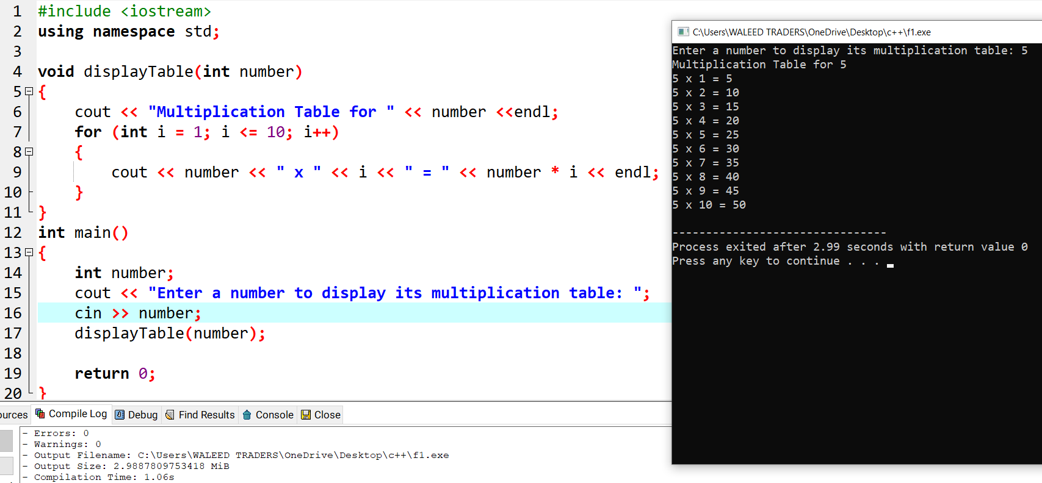

# TASK 2:

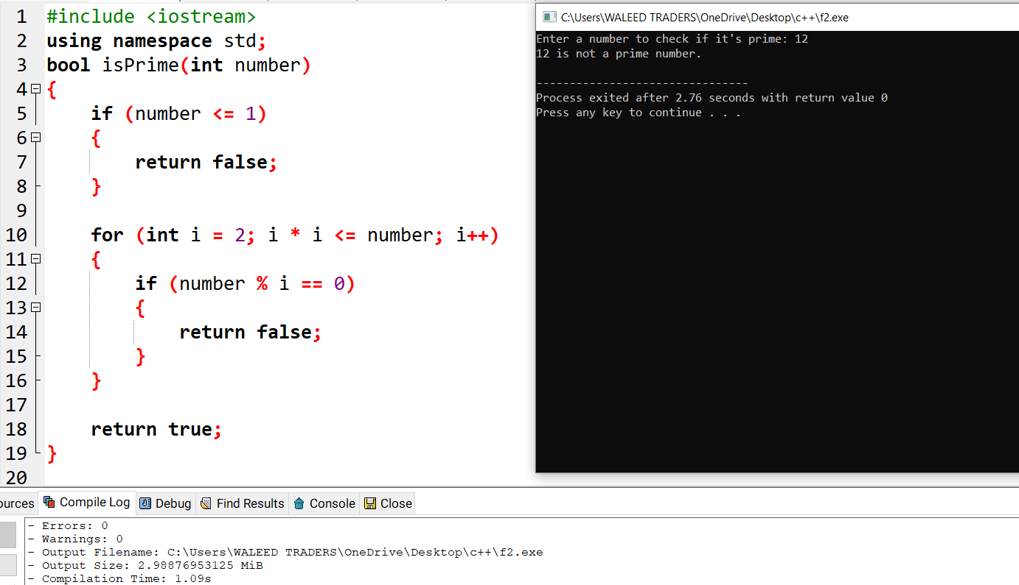

# TASK 3:

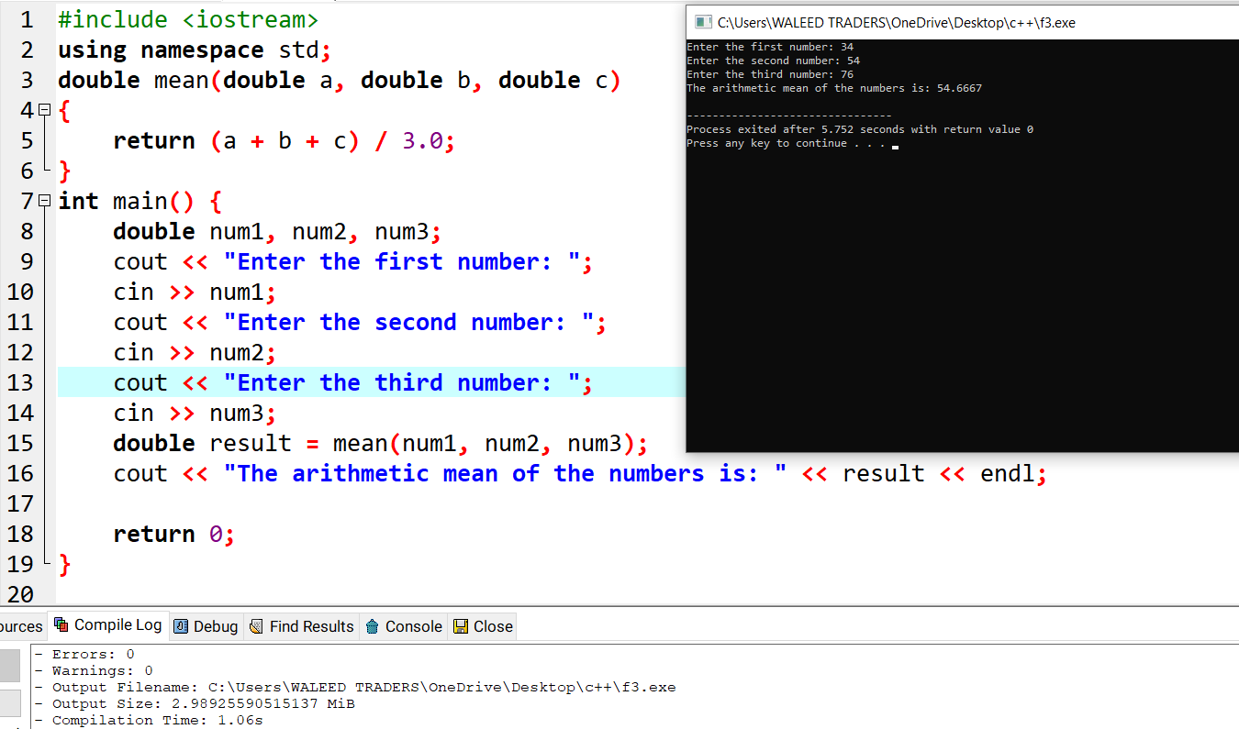

# TASK 4:

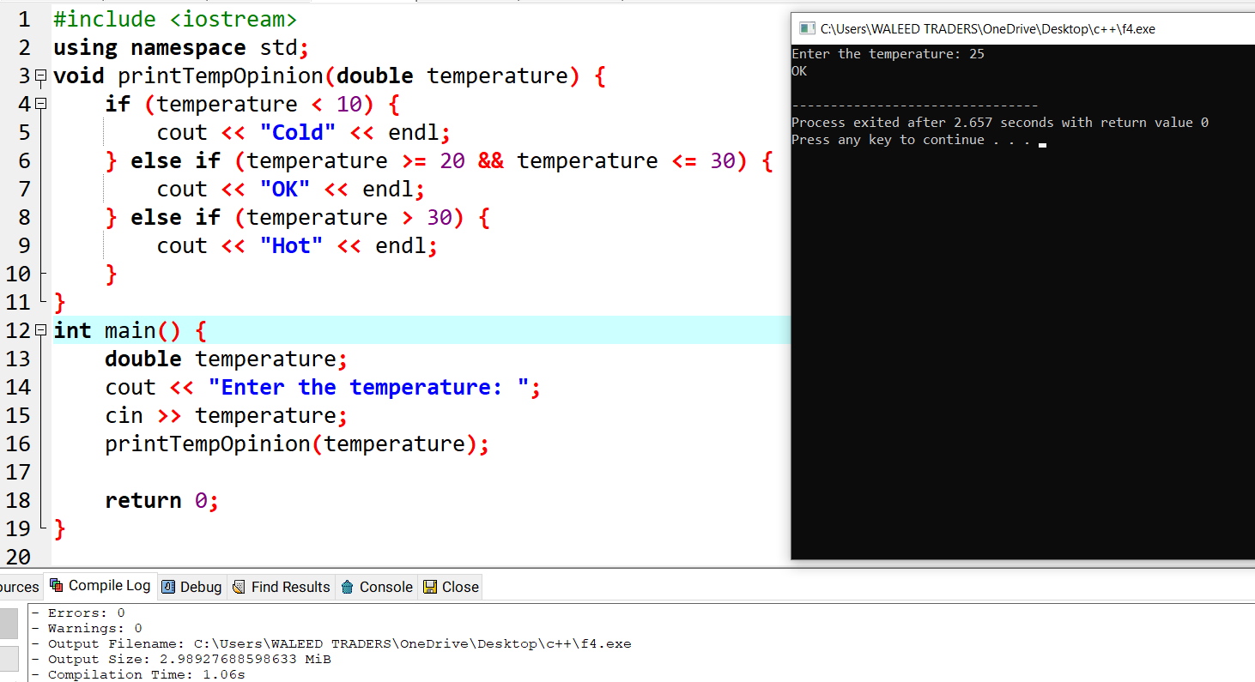

# TASK 5 :

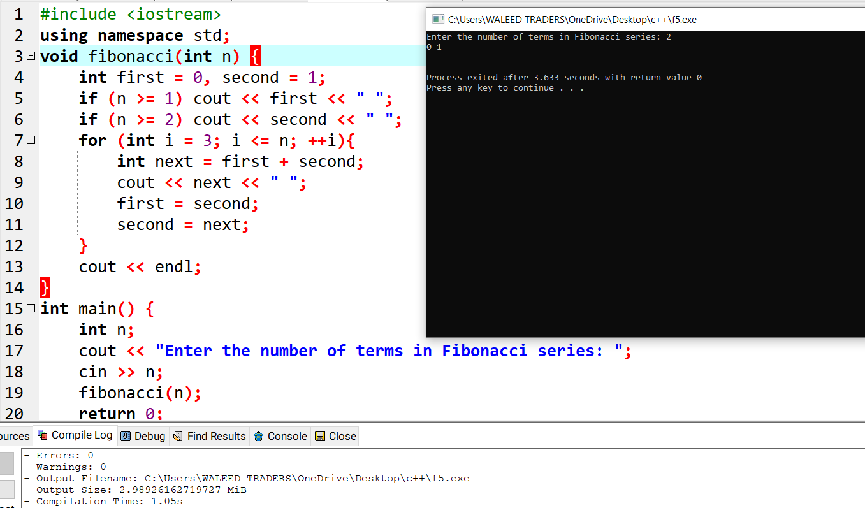

# TASK 6:



